Herefordshire & Borders Off-Road League 2022
Race 4
Westons Cider Orchards, The Bounds, Much Marcle, Ledbury, HR8 2NQ
Wednesday 27th July 2022
7:30pm Start.

Ledbury & District Harriers are proud to host the last race in the Summer Off-Road Series. Thank you to Westons Cider for allowing us to host the race in their orchards and for the use of the parking and toilet facilities.
The venue is signposted off the A449 from both Ledbury and Ross On Wye. The What 3 Words location is: slides.kitten.auctioned.
Please park where instructed by the marshals. The start is an approximate 5 minute walk from the car park, again please follow marshals instructions. DO NOT ENTER THE WESTONS SITE.
The course is a two lap course with one minor road crossing. The second lap is slightly different so please follow the marshals directions.
First lap follows marshal points:
Start, 1,2,4,5,6,3,7,9,10
Second lap follows marshal points:
Start,1,2,4,5,6,3,7,8,10
The route is approximately 4.75 miles, the route will be marked out with direction arrows and tape, please keep to the perimeter of the orchards.
JUNIORS route: One lap of the course, following the second lap route, approximately 2.5 miles.

Race Referee: Peter Smith
England athletics Race Licence Number: CC2022/0411
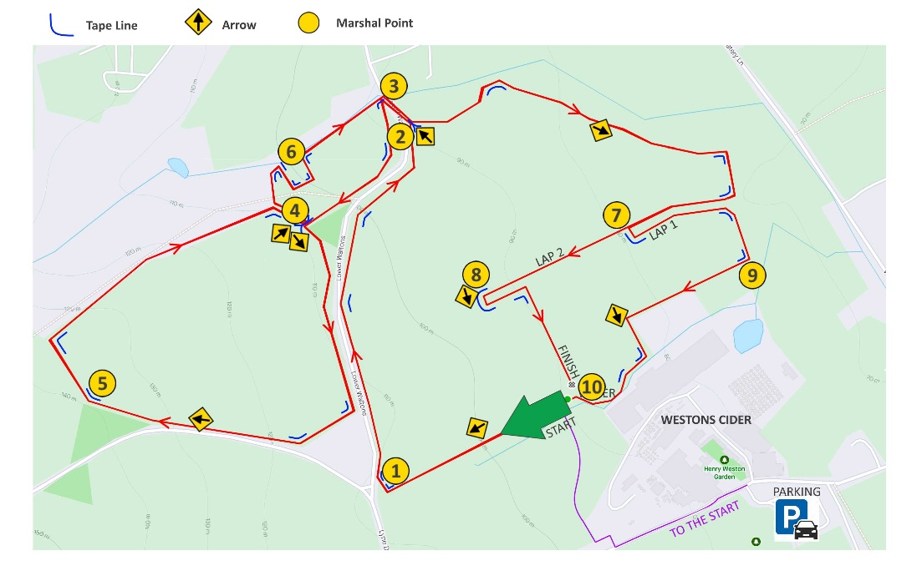
The presentation will be back at the Scrumpy House restaurant where Weston’s are providing tokens for a free ‘half. These can be collected as you finish.

